### trout-derbyWL1474

P.O. Box 626

Gardnerville, NV 89410

***Kids’ Fishing Derby***

**Board**

###### Lampe Park, Gardnerville, NV

**June 7thand 8nd, 2025**

**Members**

The Kids’ Fishing Derby is Back!

Dear Derby Sponsor,

The great success of the 2024 derby was due largely to the outstanding support we have received from this community and you as a Derby sponsor. The 2024 derby attendance was 1,123 children, ages 3 to 12, with their families. Children that participate in the Derby are provided with everything they need to have a fun fishing experience, free of charge.

There are three ways for you to participate: (**1**) Cash donations, (2) Raffle prizes and (**3**) Business banners. See the attached form for the details of each level of support. If you are able to donate to the Derby this year, please fill out the **attached** form and return it to the Kids’ Fishing Derby at P.O. Box 626, Gardnerville, NV 89410. 100% of your donation will be used to purchase fish, bait, tackle, infrastructure, prizes and supplies for the kids.

The Kids' Fishing Derby, Inc., a non-profit corporation under the laws of the State of Nevada, is exempt under Section 501(c)3 of the Internal Revenue Code, and contributions to the Derby are tax deductible. Our Tax I.D. Number is 88-0283825.

Please be patient with us as we rebuild the KFD committee, COVID took its toll on the committee, too, and please reach out to us if you would consider joining the committee. See volunteer positions at [www.dcnvkidsfishingderby.org](http://www.dcnvkidsfishingderby.org). To volunteer, e-mail us at dckfdvolunteers@gmail.com.

In closing, we want to say ***“THANK YOU”*** for supporting the Kids' Fishing Derby. We appreciate your contribution and look forward to working with you to keep this event the biggest and the best, free kids’ fishing derby in the Western states. Please feel free to contact a Board or Committee member if you have any questions. In addition, I can be reached at (775) 690-9665. Our fundraising/sponsorship chairman, Tom Zogorski, can be reached at (775) 781-4754 or tomzgolf@earthlink.net

Sincerely,

Stewart Hill

President

2025 Kids’ Fishing Derby

775-690-9665

### Thanks for your continuing support

President

Stewart Hill

775-690-9665

Vice President

Kevin Jenkins

Treasurer

Jim Roorda

Secretary

##### **Committee**

##### **Members**

John Hefner

Anita Hefner

Debbie Cole

Bob McPherson

Danny Lozano

Bob Ellis

Tiffany Ellis

Bill Hart

JJ Hubbard

Joe Lonero

Joscelyn Reid

Carol Barbish

Melissa Strazi

Tom Zogorski

Gary Beadle

Sky Dwinell

Jessica Jenkins

Doug Busey



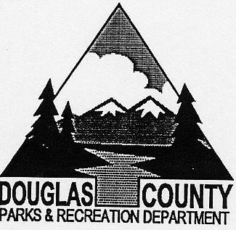

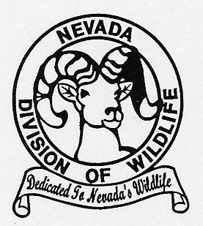

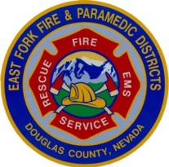



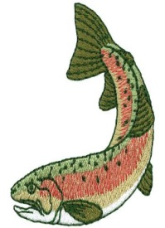

***Kids’ Fishing Derby***

P.O. Box 626

Gardnerville, NV 89410

**Board**

**June 7th and 8th, 2025**

###### Lampe Park, Gardnerville, NV

**Members**

President

Stewart Hill

**Thanks for your continuing support**

775-690-9665

**Over 30years of putting smiles on kids’ faces – join us for the 2025 event**

**1. TO DONATE CASH:** Please complete the information below and return this form with a sponsor check to the Kids’ Fishing Derby, P.O. Box 626, Gardnerville, NV. 89410. Four levels of sponsorship:

a. **Platinum Level ($1,000.00 or more)** you will receive a sponsorship plaque and a business banner. Your banner will state that you are a Platinum Level sponsor.

b. **Gold Level (at least $500.00)** you will receive a sponsorship plaque.

c. **Silver Level (at least $100.00)** you will receive a sponsorship certificate.

d. **Bronze Level (less than $100.00)**

**2. TO DONATE RAFFLE PRIZES:** Please complete the form below. Return via mail and we will make arrangements with you for pick-up of your raffle prize.

**3. TO PURCHASE A NEW BUSINESS BANNER:** To be displayed at the Derby**.** Please fill in your company information below and return this form with your sponsor check for the sum of $175.00 to the Kids’ Fishing Derby, P.O. Box 626, Gardnerville, NV. 89410. All banner orders must be received by **MAY 2nd, 2025** to give us time to have them made.

**RETURNING BANNER SPONSORS:** We have retained most prior year banners which require a $100 donation (assuming no changes) to be displayed at the Derby. Please re-hang my banner during the 2025 Derby.

Enclosed is my Check #_____________ for $100.00

## Please Print:

COMPANY NAME: ___________________________________________________________

CONTACT NAME: ___________________________________________________________

ADDRESS: _________________________________________________________________

PHONE: ___________________________________________________________________

**CASH DONATION** $_______________________ Check # __________________________

**RAFFLE DONATION** (item)___________________________________________________­_

**NEW BUSINESS BANNER** ___________($175.00) Check # _________________

BACKGROUND BANNER COLOR (Please circle one) RED WHITE BLUE

LETTER COLOR (Please circle one) RED WHITE BLUE

BUSINESS LOGO ON YOUR NEW BANNER—SEND VIA EMAIL TO tomzgolf@earthlink.net

Vice President

Kevin Jenkins

Treasurer

Jim Roorda

Secretary

##### **Committee**

##### **Members**

##### John Hefner

Anita Hefner

Debbie Cole

Bob McPherson

Danny Lozano

Bob Ellis

Tiffany Ellis

Bill Hart

JJ Hubbard

Joe Lonero

Joscelyn Reid

Carol Barbish

Melissa Strazi

Tom Zogorski

Gary Beadle

Sky Dwinell

Jessica Jenkins

Doug Busey







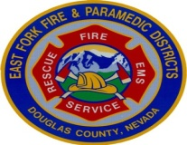

**Thanks for your continuing support**

